HIDDEN COSTS
OF YOUR
TECHNOLOGY PURCHASE

If technology gives your organization a competitive edge, you are familiar with how expensive it is to keep it current. Now, consider that at times, the purchase price of your technology is only a fraction of the cost of the total cost of ownership. In this eBook, we uncover the 8 hidden costs you’ll encounter as part of the lifetime cost of your technology purchase.

HIDDEN COSTS

- Installation
- Training
- Support
- Service Calls
- Add-Ons
- Software Updates
- Security 8.Retirement/Disposal

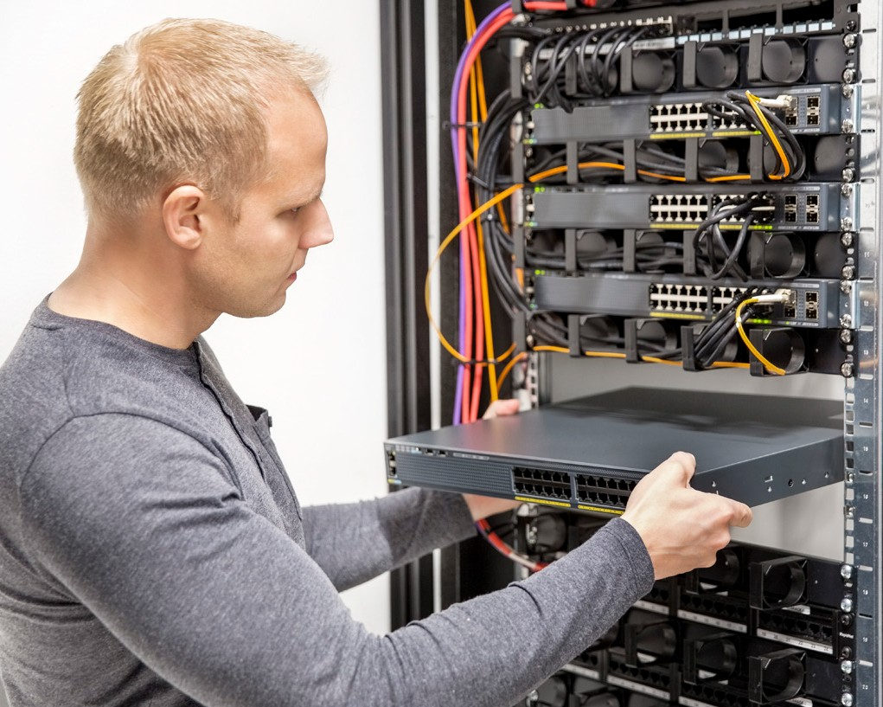

Once you have your new technology onsite, you’ll need an expert to ensure it is installed and connected to your organization’s network. Depending on the complexity of the technology, this can cost as much as the purchase price of the equipment itself.
INSTALLATIONN

TRAINING
Once your technology solution is installed, your team will need to know how to use the new features. Bringing in an expert or training one of your team members as an expert can be an unexpected cost.

Need somebody to run updates, troubleshoot issues with your accounting platform, or help a team member who can’t connect to the network? That is going to cost you. Whether it is the cost of hiring somebody to maintain your new technology or outsourcing an on-call technician, the fees for support add up quickly.
SUPPORT

SERVICE CALLS

It is one thing to have to call somebody for help, but if you need somebody to come onsite and troubleshoot an issue, you could be looking at anywhere from $100 - $200 per hour. Depending on how severe the technical issue is, you may need to spend even more to replace a piece of equipment.

ADD-ONS

Don’t forget about your growing organization. You’ll need more team members to support that growth, and those new additions will need the same technology as the rest of your team.

SOFTWAREUPDATES
Some of today’s technology could be described as just a shell that you load software onto. While it is important to have updated equipment, the software programs you use to run your business can be just as expensive to update since you may have to do it more frequently.

SECURIT Y

This important element of protecting your company from viruses or malicious IT attacks can be expensive to implement, but it is unquestionably more expensive if you have a breach. Remember to be proactive rather than reactive to a security threat before it’s too late.

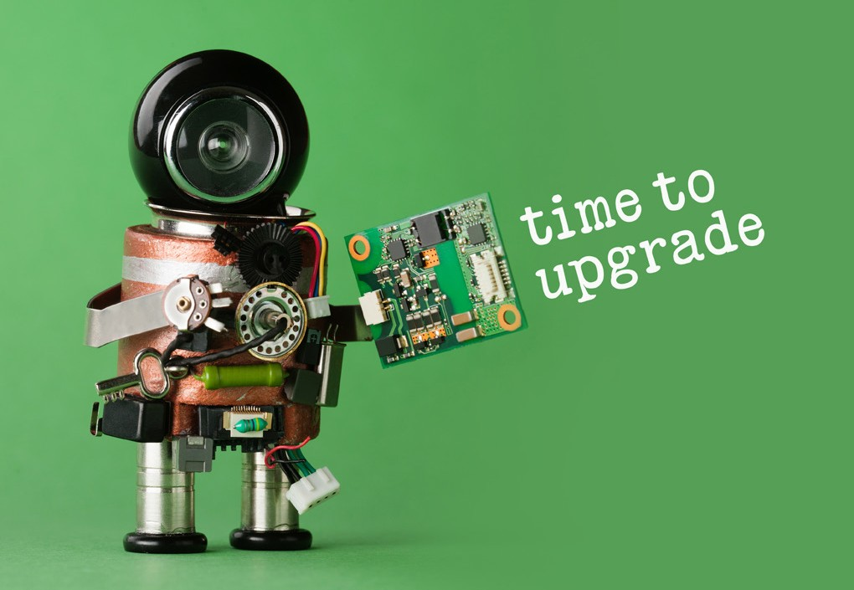

RETIREMENT/DISPOSAL

When the time comes to upgrade your technology, you’ll need to come up with a game plan on what to do with your old technology. Believe it or not, it can cost you more to dispose of the equipment properly than to just put it in the dump.

With our program, we include everything in our monthly payment so you won’t be hit with unexpected fees or have to budget for spikes in your IT spend.
CONTACT US

Applied Technology Group

(260) 482-2844

Info@atgfw.com

We hope to hear from you.

